FRIENDS AND FAMILY TEST
Results for July 2024

Thank you to all the patients who completed a friends and family test survey in July 2024.

How likely are you to recommend our practice to family and friends if they needed similar care or treatment?
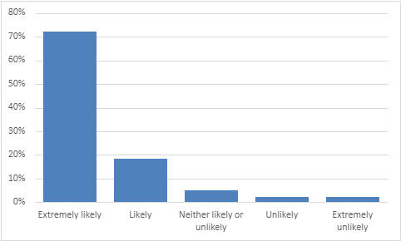
72% are extremely likely to recommend the practice
19% are likely to recommend the practice
5% are neither likely nor unlikely to recommend the practice
2% are unlikely to recommend the practice
2% are extremely unlikely to recommend the practice

If we could change one thing about your care or treatment, what would it be?
- Nothing, all staff are fabulous. Brilliant service.
- I cannot praise everyone highly enough. Thank you for your care and professionalism.
- Justine, you are a special lady. You cannot teach the way you deal with patients, thank you.
- Justine was super friendly and helpful. Ms Peel was fantastic (as always). She’s incredibly knowledgeable, thorough and understanding. Couldn’t fault her.
- Dr Hart is the best GP ever. Dr Hart was excellent.
- Dr Hart is a most welcome doctor to the practice and a great asset. She is very caring and lots of empathy.
- Dr Rawson was so lovely and caring. He’s a credit to our surgery.
- Dr Rawson always listens, acts upon concerns and always helps.
- Dr Harris is very attentive, helpful and reassuring. Dr Harris was excellent.
- Dr Challa is great.
- My latest experience has been my best at the surgery. The triage part worked well and Dr Harris went above and beyond with helping me and giving me advice.
- Big thank you to Dr Brown for putting my mind at rest.
- Wonderful service once again from Sue on the desk to Dr Brown, thank you.
- Felt comfortable and at ease with Tracey. Lovely lady to talk to and explained everything in detail. Saw Tracey, excellent consultation and advice.
- Tracey was excellent. Very professional and personable.
- The Health Care Assistant who did my vaccination was excellent.
- My experience has been first class. Thank you, Jean, Carol and the receptionists.
- Carol was fantastic. The nurse was brilliant, very understanding and caring.
- Front office staff are exception, always friendly. All staff are extremely helpful.
- Excellent service. Reception went above and beyond to help.
- Better communication and more face-to-face appointments.
- Waiting times for telephone consultations need to be addressed. A 3-4 week wait for a 2-minute phone call really is not acceptable.
- Shorter wait times for routine appointments.
- If the doctor or nurse is running late, please notify on the patient board.
- Don’t like the new booking system.
- Enhance patient engagement by actively listening to their concerns and demonstrating empathy and respect during interactions.
- Privacy at the reception desk.
- The doctor was quite rude and patronising.
- I would love to see an aquarium in the surgery. It would be good for the children to watch. Also it would make the patients relaxed.

